Name: Class: Mark:

Convert the following binary values into denary: [2]
  - 00011011
  - 11100110

Circle the binary value below that represents the denary value 87? [1]
  - 01011010
  - 11000100
  - 01010111
  - 00011010

Convert the following values to and from Hexadecimal: (Show your working). [8]
  - Denary 37 to Hex
  - Denary 59 to Hex
  - Hex 11 to Denary
  - Hex 2F to Denary
  - Hex 1A to Binary
  - Hex 16 to Binary
  - Binary 0011 0111 to Hex
  - Binary 1101 1111 to Hex
- Multiply the binary value 0011 0010 by 2, by using a logical shift. [1]

- Colours in art packages are often given using hexadecimal as illustrated below with #00ccff.
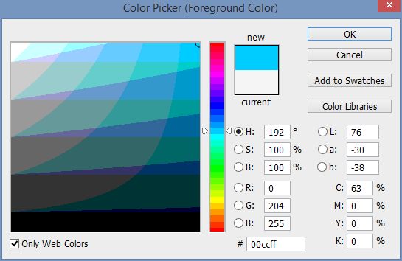
Explain why hexadecimal is used rather than the actual 24-bit colour value. [2]

- Add 00100111 to 00101010. You should include your working. [2]
 | 0 | 0 | 1 | 0 | 0 | 1 | 1 | 1
+ | 0 | 0 | 1 | 0 | 1 | 0 | 1 | 0

- Add 00100111 to 00111010. You should include your working. [2]
 | 0 | 0 | 1 | 0 | 0 | 1 | 1 | 1
+ | 0 | 0 | 1 | 1 | 1 | 0 | 1 | 0

- An error occurs when you try to add 11011001 to 11100100 and store it as an 8-bit number.
Explain the error that occurs. [2]

[Total 20 marks]

